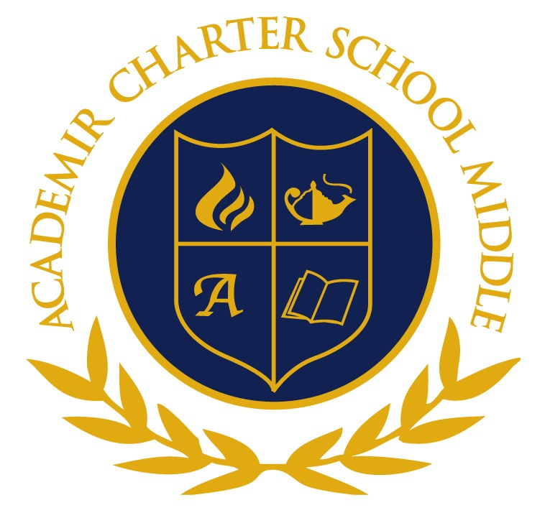
Title I School

Dear Parents/Guardians,
Welcome to the 2017-2018 school year. My name is Ms. Huizinga. I teach United States History for 6th grade, both regular and advanced classes.
Throughout these pages, you will find information that will be useful throughout the school year. Please take the time to go through each of them. Materials presented in this syllabus can also be found on my website http://msh-acsm.weebly.com.
Please feel free to contact me throughout the school year with questions or concerns you may have at k.huizingaacsm@gmail.com or through my website contact page information. I look forward to an exciting and successful school year.
Sincerely,
Ms. Huizinga
Class Overview
This year, we will be traveling through United States History. We will be starting with the settlement of the United States and ending with the reconstruction of our country just after the Civil War. There will be a focus on reading skills, writing, and application of what we know to what is going on in our world today.

Classroom Policies & Procedures
1. No gum, food of any kind, or open beverage containers is allowed. Water only please.
2. Please use proper language in the classroom. Inappropriate comments and language will not be tolerated.
3. Arrive on time to class. After three tardies to class, parent contact and a detention will be issued.
4. Raise your hand if you have a questions, comments, or concerns.
5. All assignments must be turned in on the assigned due date. No assignments will be accepted late unless you have an excused absence.
6. Bathroom passes will be provided on a need basis.
7. Students are expected to be prepared for class and participate in class discussions.
8. All AcadeMir Charter School Middle rules and regulations apply.
Class Materials
Many items are requested on the supply list and should be brought in to the homeroom teacher. Please note, these items are to come to school with each student every class period for them to be properly prepared for class:

- 1 notebook
- Pens and pencils
- Loose Leaf Paper Wide Rule (in a binder)
- Highlighters (Any Color)
- Mini Stapler
- Scissors/ glue sticks (for interactive in-class activities)

Absences
All students absent from class (unexcused or excused) are responsible for getting any missed assignments or notes.
Unexcused Absence
In the event of an unexcused absence, any missed assignments or exams will receive a "Z" as the academic grade.
Excused Absence
In the event of an excused absence, a student has 3 days to make-up any missed assignments or exams. After three days, the assignment or exam will remain a "Z".

Home Learning
Home learning is posted on my website and on the whiteboard every day. All home learning assignments are to be submitted on the assigned due date. No late work will be accepted.
Many home learning assignments will be done online through ConnectEd and Study Island. If there are any issues with computer access or internet, please email me as soon as possible.

Remind App
The Remind app is free and is utilized for important information. All class reminders and school announcements are through this app. Parents are highly encouraged to sign up as well as students.

To sign up for the 6th Grade U.S. History remind class:

Log on to https://www.remind.com/join/khuiz

Or

Text @khuiz to 81010

Academic Honesty

You are expected to maintain the highest standards of academic conduct. When you cheat, you are robbing yourself of knowledge, the learning experience and my company. I will be holding you to high ethical standards to which you will be expected to maintain at all times.
You are guilty of cheating whenever you present work as your own and you did not do. You are also guilty of cheating if you help someone else to cheat. Any student(s) who is discovered cheating will receive a “0” for that assignment and have the work documented in their portfolio. A referral may be issued based on the assignment.
Grading Scale
A 100-90
B 89-80
C 79-70
D 69-60
F 59-0

Assessment Percentage
Classwork/ Participation 10%
Home Learning 20%
Projects 15%
Quizzes /Projects 20%
Tests 35%

Dear Parents/Guardians,

I truly look forward to working with you and your son/daughter this school year. I am very passionate about History and effect it has on our society today. Please, feel free to contact me at any time if you have questions or concerns. Your child also knows that he/she can meet with me before or after school if he/she has any questions that need to be addressed outside of class.

For my own records, I would greatly appreciate it if you would provide the following information so that I may be able to contact you and share any pertinent information regarding the class or your child. Thank you very much for your time!

Sincerely,
Ms. Huizinga

My child and I have reviewed and understand the expectations and policies as presented in the syllabus. We also acknowledge the availability of all class information and the syllabus online through the teacher website.

______________________________________ ______________
Students Name Period

______________________________________ ______________
Students ID number Date

______________________________________ ___________________
Parent/ Guardian’s Print Name Relationship to Student

How would you like to be contacted? _________________________(Home)
_________________________(Work)
_________________________(Cell)
_________________________(E-mail)

